The program is split up into four distinctive classes.

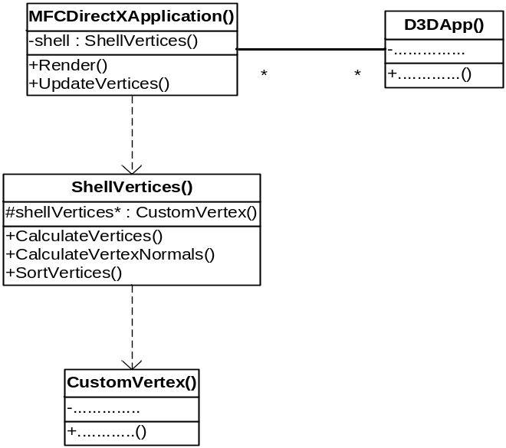

Figure 1: UML model of the class hierarchy

At the top of the hierarchy, lies the MFCDirectXApplication() class. This is the main file which contains the integrated render and user interface functions. It ingeniously inherits the functionality of the Microsoft Foundation Class (MFC) structure, which provides the program with user interface functionality. The MFCDirectXApplication() class includes the services provided by the ShellVertices() class. The Shell Vertices class contains the number of CustomVertex() object elements required to display the shell structure. The D3DApp() works in conjunction with the MFCDirectXApplication() class to handle initialisation and closure of the program.

All shell transformations are handled by MFC interface items. When a button is clicked, slider moved, combo box changed etc. the MFCDirectXApplication() class handles it. The messages it receives from each of the interface items are mapped onto their specific handler function. Within these handler functions, the state of the user interface items is updated along with the state of the rendered shell.

What algorithms does it use?

There are three core algorithms that are used by the main program MFCDirectXApplication(). Every time the physical structure of the rendered shell is altered, the main program calls functions CalculateVertices(), CalculateVertexNormals() and SortVertices(). These are found within the ShellVertices() class and are used by the main programs UpdateVertices() function. CalculateVertices() uses the mathematics that calculates the 3D logarithmic spiral path. The graphics technique called sweeping is then implemented, which involves taking a 2D shape and moving it along discrete points on a path. The sweep shape is then mapped onto these points; the calculated vertices (points) contribute to the shells surface.
The CalculateVertexNormals() function contains an algorithm that calculates the vertex normals on the outer surface of the rendered seashell.
The SortVertices() function takes the calculated vertices and normals, then
These functions are explained in more depth in Section 4 of this report.

How do these compare with alternatives?

-- Alternative implementations for the above included using a mesh, an that other buffer.

What were the main design decisions you took, and their justifications?

One of the main design decisions I took anchored on the viability of creating an effective user interface in the available time. There were two main ways of creating a GUI using visual C++, use either MFC or Forms. The latter is the newest way of creating user interface components. However, MFC has better documented tutorials. The main problem apparent with GUI components was how could they be integrated successfully with DirectX9. Documentation about this particular problem was difficult to find. The best answer available at the time was Microsoft’s DirectX/MFC template. The DirectX9/MFC template is available in the software package Visual Studio after the DirectX9 software development kit is installed.

The only way I could see my rendering program working successfully with MFC was to create a new DirectX/MFC template derived program. Through trial and error I inserted my shell vertices code in place. The template provided the bare essentials i.e. the shell rendering display and an area where MFC GUI components could be placed. The functions available previously through keyboard via windows and DirectInput could now be made visible to the user via the interface. Using the Visual Studio resource window, templates of GUI components could successfully be ported to the DirectX/MFC template window. A message map was written for each component to link its action to the appropriate change in variable values. This simply meant writing a function for each GUI module then mapping it to that function. The function then simply read in the value and assigned the value to the appropriate variable.
This is replaced

The software comprises of two main components:

- The shell rendering display
- The shell rendering controls

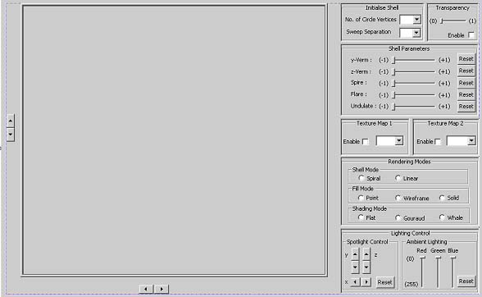
Shell rendering display
Shell rendering controls
Figure 1: GUI

In researching, a number of programming languages and graphics libraries were found to be available. I chose to use C++ and DirectX because they are the best-documented and up to date graphics programming software tools presently on the market.
Both the shell rendering display and rendering controls are programmed in C++. The controls form part of the user interface, whilst the display outputs the rendered shell. The user interface is formed from MFC (Microsoft foundation class) library components, whilst the rendering display is produced using the Microsoft Direct3D version 9 library.

